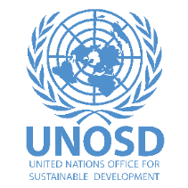
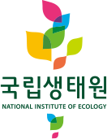
IUCN Leaders Forum Jeju 2022
UNOSD side event: Ecosystem Restoration for a Sustainable Future: Principles, Tools and Acceleration Needs
Friday 14 October 2022, 9:30-11:00am, Hall 201, ICC Jeju, South Korea

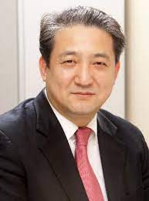
Speaker list
Mr. Chun Kyoo Park, Head of Office, United Nations Office for Sustainable Development (UNOSD)
Mr. Chun Kyoo Park is the Head of Office for UNOSD as of September 2020. He previously served for roughly 30 years in Korea’s Ministry of Environment. Tackling climate change has been his major concern and he produced many achievements such as setting up Korean National Mitigation Targets. Mr. Park also worked as the First Secretary of the Republic of Korea Mission to the UN in charge of works related to the UN General Assembly 2nd Committee and the Commission of Sustainable Development.

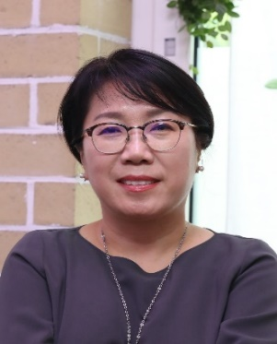
Dr. Eunjin Park, Division of Climate Change & Ecology Director, National Institute of Ecology of Korea
Park Eun-Jin is a Director of Climate Change & Ecology Division in the National Institute of Ecology, Korea. She received her PhD from the Graduate School of Environmental Studies in Seoul National University and added up research experience on soil carbon sequestration for mitigation of climate change at Michigan State University. She serves as a member of the National Unification Advisory Council, Border Area Policy Council, Korea Committee of UNESCO MAB. She conducted research on assessment of ecosystem services and conservation of the DMZ ecosystem and is currently leading research teams on ecological impacts of climate change and ecosystem-based adaptations.

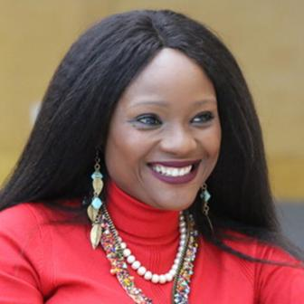
Dr. Musonda Mumba, Secretary General, Ramsar Convention on Wetlands (video message)
Dr. Musonda Mumba is the 7th Secretary General of the Convention on Wetlands. She has over 25 years of global experience in environmental management and sustainable development and previously worked for the Environmental Council of Zambia, UNDP and UNEP. She is the founder of the Network of African Women Environmentalists (NAWE) and she has received numerous accolades for her work, including being named one the 100 most influential African women.
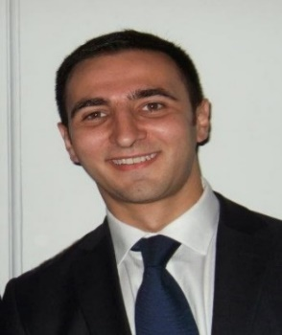
Mr. Benjamin Singer, Senior Forest and Land Use Specialist, GCF
Benjamin Singer supports the design of transformational projects and programmes on forests, land use and ecosystems. Prior to this, he worked as a forest financing expert at the United Nations Forum on Forests where he supported countries in mobilizing financing for sustainable forest management. When the pandemic broke out, he joined the UN Secretary-General’s Office to support the UN’s COVID-19 response on financing for development. Mr. Singer holds a PhD in tropical forest policies, a Master’s degree in nature conservation and a bachelors in anthropology.

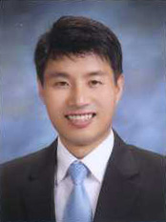
Mr. Junghyun Kim, Partnership Specialist, FAO Partnership and Liaison Office
Mr. Kim Jung Hyun is a Partnership Specialist at FAO. Prior to joining FAO, he worked for the WEF, UNDP, and managed the WEF’s Global Future Council (GFC) on the Korean Peninsula. He has also spent 13 years managing various international cooperation programmes at the Korean Local Government (City of Seoul and Incheon). Mr. Kim holds a Master of International Relations and National Security from Yonsei University and a Bachelor of Business Administration from the University of Canberra. He is currently a Ph.D. candidate in the Climate Finance at In-Ha University in Incheon.
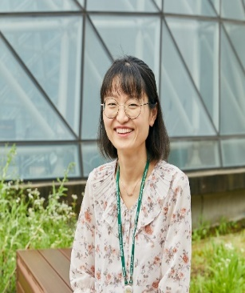
Dr. Jeongeun Lim, Team Head, National Institute of Ecology of Korea
Jeongeun Lim is Team Head of the Mammal Research Team at the Research Center for Endangered Species of the National Institute of Ecology, Korea. Before joining the NIE, she was a program officer at the Wildlife Conservation Society-China program. She received her B.A. in Biological Sciences from the Korea Advanced Institute of Science and Technology, her MSc from the Imperial College London, and her Ph.D. from the University of Wisconsin-Madison. Her primary research interests are in the field of wildlife conservation.
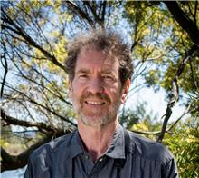
Mr. Doug Watkins, Chief Executive, East Asian-Australasian Flyway Partnership
Mr. Doug Watkins has over 40 years of involvement in the conservation of migratory water birds and their habitats across the East Asian-Australasian Flyway. He has previously taken on a variety of training, technical and policy roles - including the leading role in Wetlands International – Oceania, as an Ecological Consultant to Government and a sub-contractor on two Asian Development Bank wetland related projects in China. He has also been a Visiting Adjunct Professor at the Northeast Institute of Geography and Agroecology in China.
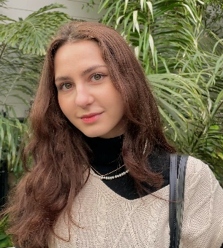
Ms. Noémie Benfella, 6th SDGs Youth Summer Camp Participant
Ms. Noémie Benfella completed a bachelor’s degree in social sciences at Sciences Po Paris, majoring in Economics and Society. She previously interned at France’s Bank of Territories and studied at Yonsei University before joining UNOSD as an intern.

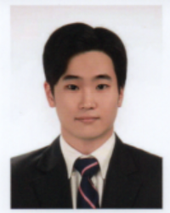
Mr. Jae Lee, 6th SDGs Youth Summer Camp Participant
Mr. Jae Lee completed his undergraduate studies at the University of Texas at Austin, with a bachelor’s degree in International Relations and Global Studies. He is currently a graduate student at Yonsei’s Graduate School of International Studies, studying International Security and Cooperation. He has previously interned for Korea House of Solidarity, SM Line, and UNOSD.
-------------------------------------------------------------------------------------------------------------------------------------
Moderator
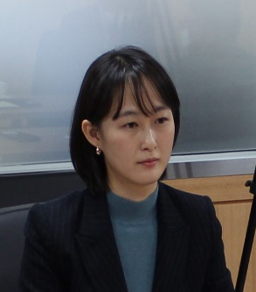
Ms. Yujeong Kim, Senior Sustainable Development Officer
Ms. Yujeong Kim is the Senior Sustainable Development Officer at UNOSD. She contributes towards the capacity building of Member states for achievement of sustainable development goals through organizing capacity building events, developing training materials, undertaking policy research studies, and building partnerships with various organizations. Prior to joining the UNOSD, Ms. Kim worked as a senior specialist at the Ministry of Environment of the republic of Korea where she led policy design and implementation on air quality, environmental health, water, and climate change.

